✅ Q1. Describe the two (or, if applicable, three) dimensions underlying the perceptual maps that you generated. Based on these maps, how do people in this market perceive the Infiniti G20 compared with its competitors?

🔹 Dimension 1 (explains 54.6% of variance)
This axis separates brands based on overall prestige and refinement vs. perceived low quality and poor value.
- On the left of Dimension 1 are attributes like:
  - Prestige, Successful, Quiet, Attractive, and Overall quality
- On the right side:
  - Unreliable, Poorly Built, Poor Value, Uncomfortable, and Common
✅ Interpretation:
Dimension 1 reflects a "Luxury/Prestige vs. Low-Quality/Low-Value" spectrum.

🔹 Dimension 2 (explains 18.7% of variance)
This axis appears to distinguish between roominess and comfort vs. sportiness and compactness.
- The top is associated with Roomy, S2, and to some extent Quiet
- The bottom aligns with Sporty, AvantGarde, Easy Service, and Attractive
✅ Interpretation:
Dimension 2 reflects a "Practicality/Space vs. Sportiness/Design Boldness" dimension.

🚗 Position of the Infiniti G20 (Brand #1)
- The G20 is located on the left side of the map, near BMW and Saab
- It is close to attributes like:
  - Prestige, Quiet, Successful, and Overall
- It is far from negative associations like Unreliable, Poorly Built, and Uncomfortable
✅ Interpretation:
Consumers perceive the Infiniti G20 as:
- A prestige-oriented, refined, and quiet car
- Similar to BMW, suggesting a successful positioning as a luxury vehicle
- Not seen as sporty or adventurous, but rather as professional and upscale

✍️ Final Summary:
The perceptual map shows that consumers associate the Infiniti G20 with prestige and refinement, similar to traditional luxury brands like BMW. It ranks low on attributes tied to mass-market or poorly built vehicles and does not appear to be strongly associated with “sporty” or “economical” perceptions. The two key perceptual dimensions reflect (1) Prestige vs. Poor Quality, and (2) Roomy vs. Sporty Appeal.

Dimension | Variance Explained | Interpretation | Key Attributes | G20 Position
Dimension 1 | 54.60% | Luxury/Prestige vs. Poor Quality & Value | Prestige, Successful, Quiet vs. Unreliable, Poor Value | Left side: close to BMW and Saab; perceived as refined and prestigious
Dimension 2 | 18.70% | Roominess/Practicality vs. Sportiness/Edginess | Roomy, Quiet vs. Sporty, Easy Service, AvantGarde | Mid-low on Dimension 2; not seen as especially sporty or roomy

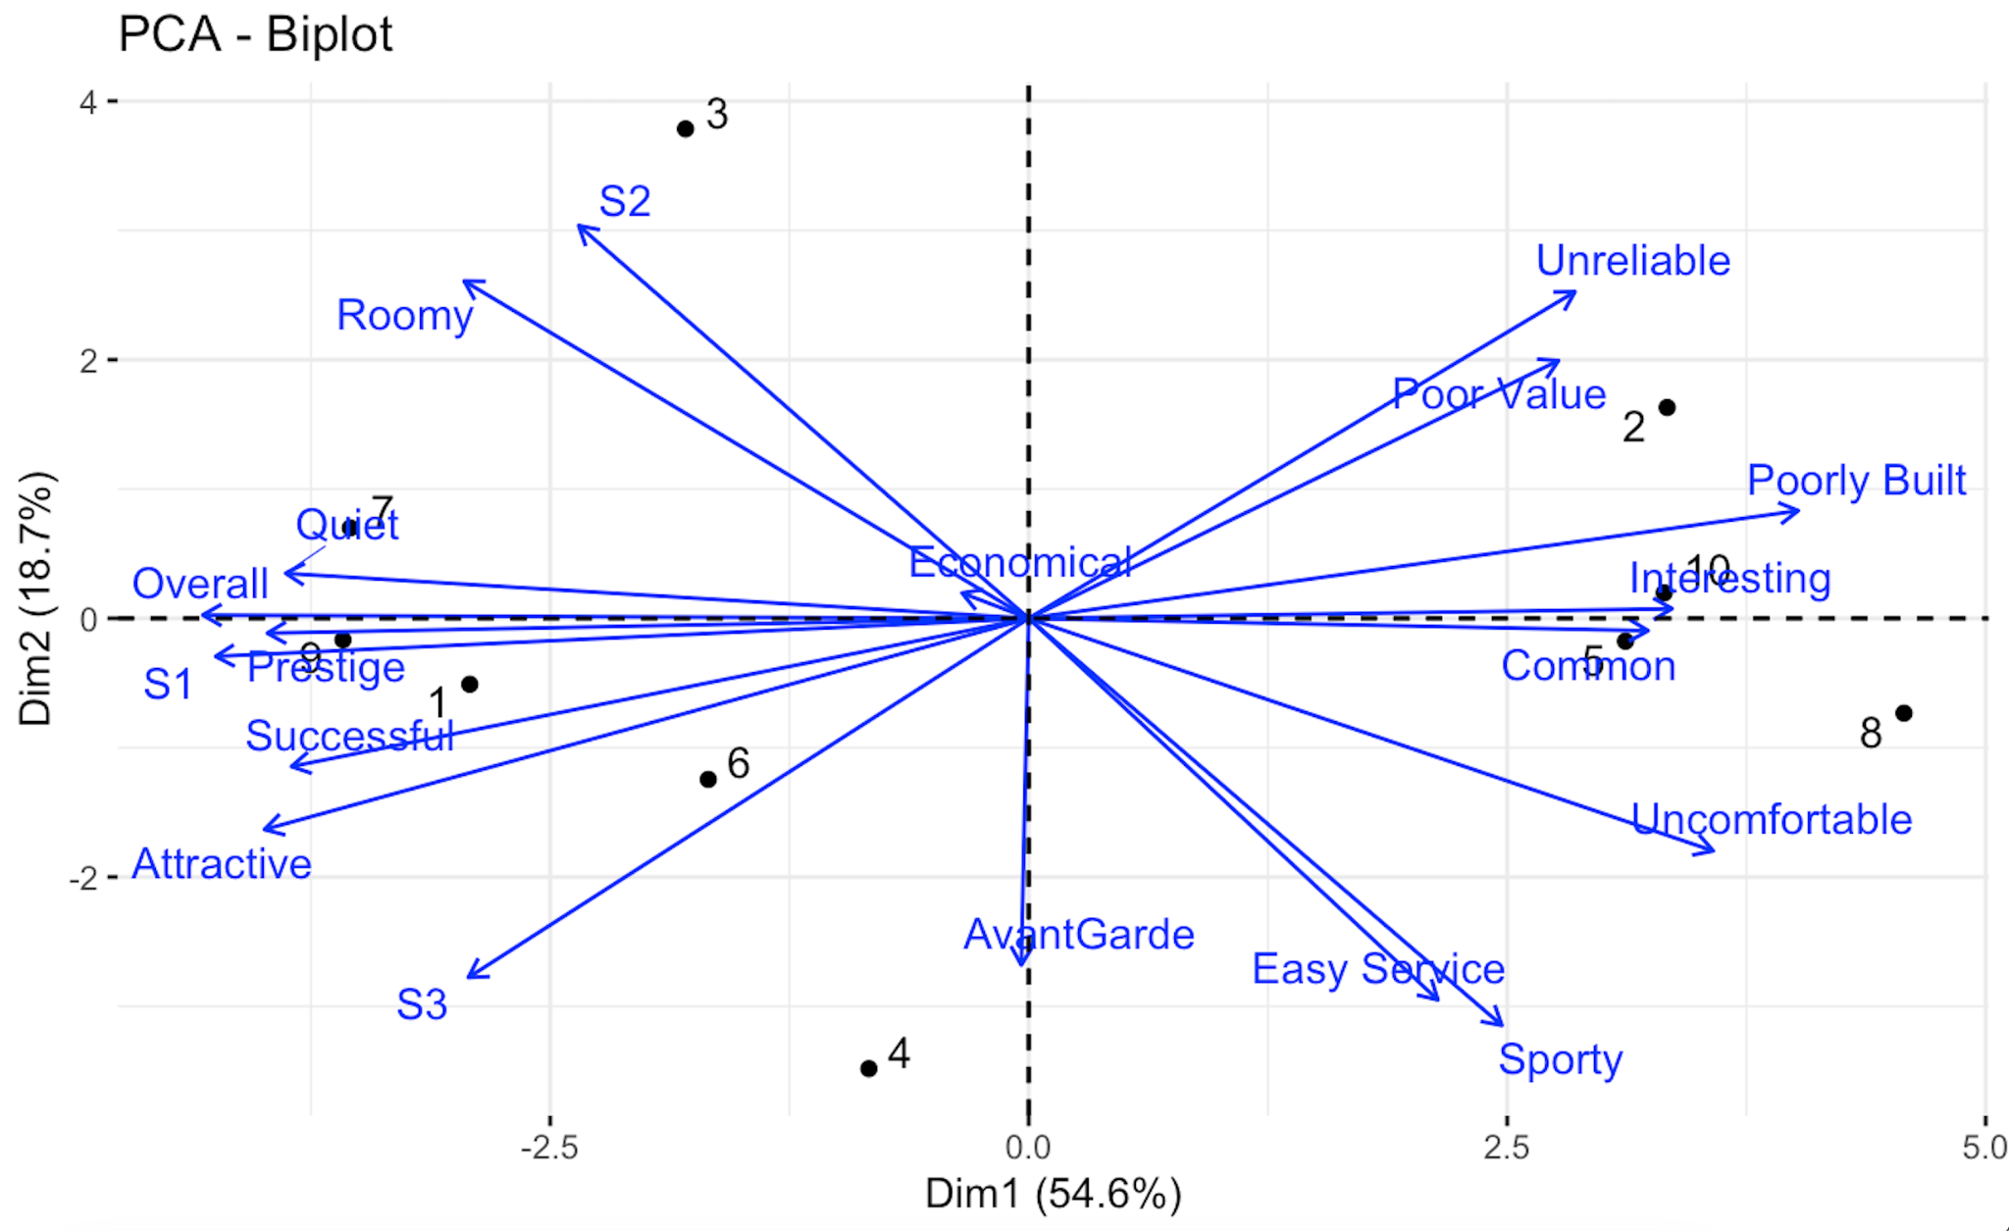

Q2.

✅ What Needs to Be Done for Q2
Infiniti claims:
The G20 is "like a BMW 318i but lower priced."
To evaluate this, we need to assess two things:

1. Are G20 and BMW perceived similarly?
From the perceptual map (Q1):
- Look at proximity between G20 and BMW
- Look at shared attribute associations (Prestige, Quiet, Successful)

2. Is the price difference meaningful for consumers?
We need to check:
- Are respondents price-sensitive?
- Does ratings_data.csv suggest they prefer G20 or BMW?
- Use average preference scores (optional but helpful)

✅ Q2 Response: Is Infiniti’s claim credible?
Infiniti’s claim that the G20 offers a “German feel” similar to the BMW 318i — but at a lower price — is partially credible, based on both perceptual attribute data and customer preference ratings. A breakdown of the evidence shows strong support on quality and value, moderate alignment on prestige, and a notable gap on sportiness and emotional appeal, which are integral parts of the “German driving experience.”

1. Perceptual Attribute Analysis
Using PCA-based perceptual mapping derived from the 15 attributes rated by respondents, we can compare how the G20 and BMW 318i are perceived:
Attribute | G20 Rating | BMW 318i Rating | Insight
Prestige | 6.4 | 6.4 | Equal – G20 matches BMW in perceived prestige
Quiet | 6.3 | 5.7 | G20 is quieter – strong luxury signal
Unreliable | 2.1 | 2.1 | Equal – both viewed as highly reliable
Poorly Built | 2.0 | 2.1 | G20 seen as marginally better built
Sporty | 4.1 | 6.3 | G20 lags significantly – a key German-car trait
Interesting | 3.6 | 5.2 | BMW seen as more emotionally engaging
Poor Value | 3.4 | 4.2 | G20 is perceived as a better deal
🔍 Interpretation:
- Infiniti matches or beats BMW on core luxury and quality perceptions.
- The value proposition is clear — G20 offers similar “quiet luxury” at a lower price.
- But G20 falls short on “feel” attributes like sportiness and engagement, which are central to the emotional appeal of German cars.

2. Preference Analysis by Segment
From the ratings data (ratings_data.csv), we assess how three customer segments responded to the G20 and BMW:
Segment | G20 Rating | BMW 318i Rating | Insight
Segment 1 – Yuppie Singles | 6.0 | 8.3 | This prestige/status-driven group clearly prefers BMW
Segment 2 – Young Families | 5.9 | 7.0 | Slight BMW preference; practicality-driven
Segment 3 – American Dreamers | 8.6 | 7.3 | G20 outperforms BMW – supports affordability + aspiration
🔍 Interpretation:
- Segment 3 (value-driven aspirational buyers) strongly believe the G20 delivers the luxury experience they want at a price they can afford.
- Segment 1 is more brand loyal and performance-focused, and doesn’t buy the claim.
- Segment 2 is neutral; both brands meet basic comfort and prestige needs.

3. Conclusion: Is the Claim Credible?
Component | Verdict | Why?
Luxury/Prestige Feel | ✅ Credible | Perceived on par with BMW
Build & Quietness | ✅ Credible | Seen as high-quality, well-built
Price Advantage | ✅ Credible | G20 is ~$2.5k cheaper, and seen as better value
Sporty German “Feel” | ❌ Not fully | Lacks performance and excitement perception
Overall for Segment 3 | ✅ Very credible | Highest preference rating – strong fit
While Infiniti’s claim is not fully credible among brand-pure or sport-focused buyers, it is highly compelling to pragmatic and aspirational customers, particularly those in Segment 3. The G20 successfully delivers much of the perceived luxury and quality of a German car, especially in quietness, reliability, and prestige, while outperforming on value. What it lacks is the full performance DNA associated with BMW — but for its price, the tradeoff is acceptable to many buyers.

✅ Question 3. Which attributes are most important in influencing preference for these cars in the three segments (S1, S2 and S3) shown on these maps? To which segment(s) would you market the Infiniti G20? How would you reposition the Infiniti G20 to best suit the chosen segment(s)? Briefly describe the marketing program you would use to target the chosen segment(s).

🔹 Segment 1: Western, Yuppie Singles (25%)

🧠 What They Value (Regression + PCA)
- Top Positive Drivers:
  - Attractive (+1.64)
  - Interesting, Economical
- Negative Drivers:
  - Prestige (−0.86), Quiet (−0.88), Uncomfortable
This may seem surprising, but aligns with young professionals who want good design and value, not overly quiet or “formal” luxury.

📍 G20 Fit:
- G20 is positioned close to S1 on the PCA map and already scores high on Attractive and Interesting.
- Regression confirms those are key preference drivers.
➡️ ✅ Best-fit segment for G20.

🔹 Segment 2: Upwardly Mobile Families (45%)

🧠 What They Value:
- Top Drivers:
  - Quiet (+1.86), Poor Value, Sporty, Roomy
- Negative Drivers:
  - Attractive (−1.85), Interesting (−1.56)
This group is more practical, prefers a quieter, spacious, reliable car.

📍 G20 Fit:
- Not very roomy; more design-focused.
- Regression confirms that G20’s key strengths (Attractive, Interesting) are turn-offs here.
➡️ ❌ Not a good fit.

🔹 Segment 3: American Dreamers (30%)

🧠 What They Value:
- Top Drivers:
  - Attractive (+2.22), Interesting, AvantGarde
- Negative Drivers:
  - Sporty (−1.53), Poor Value (−2.63)
This group values style and uniqueness, but not flashy performance.

📍 G20 Fit:
- Somewhat aligned — G20 is seen as stylish and interesting, not too sporty.
- G20 could appeal here with slight repositioning.
➡️ ⚠️ Secondary opportunity.

🎯 Recommendation Summary
Segment | Fit for G20 | Why
S1 | ✅ Best Fit | Values design, interesting styling, economical — aligns with G20’s strengths
S2 | ❌ Poor Fit | Wants quiet, spacious, less interested in style
S3 | ⚠️ Partial Fit | Likes G20’s design and uniqueness, dislikes sportiness & poor value

📢 Marketing Program (for S1)
Element | Strategy
Message | “Refined. Bold. Affordable.”
Positioning | Highlight G20’s design, Japanese engineering, upscale feel
Channels | Tech/business media, social ads, Amex co-branding
Creative | Use modern visual identity, young professional testimonials
Promos | Lease offers, trade-in discounts targeting BMW 3-series owners

✅ Conclusion:
Regression results and perceptual mapping both confirm that Segment 1 is the best target for the Infiniti G20. The car’s key appeal — attractive styling, uniqueness, and value — aligns with what S1 values most. Segment 3 could be a secondary target with minor tweaks. G20 should not target Segment 2.

✅ Question 4. What ongoing research program would you recommend to Infiniti to improve its evaluation of its segmentation of the market and positioning of its G20?

1. Improving Evaluation of Market Segmentation

🎯 Current Problem:
Infiniti's original 3 segments (S1, S2, S3) appear to have been created using managerial intuition or demographic stereotypes (e.g., Singles, Families, Dreamers).
This kind of segmentation:
- Is coarse and may overlook subgroups
- Doesn't evolve as consumer behavior changes
- May not align with actual drivers of purchase

🧪 Recommended Research Actions:

A. Behavioral & Psychographic Segmentation
Move beyond just demographics. Start gathering actual behavioral and attitudinal data:
- Purchase motivations (e.g., performance vs. safety vs. prestige)
- Media consumption habits (for targeting)
- Lifestyle indicators (urban vs. suburban, tech-savvy vs. tradition-oriented)
Use clustering algorithms (e.g., k-means or hierarchical clustering) on survey or CRM data to discover emerging buyer personas.

B. Conjoint Analysis
Use choice-based conjoint surveys to quantify:
- How different features (e.g., Quietness, Price, Prestige) trade off in real purchase decisions
- Which bundles attract each segment
This helps:
- Refine target segments
- Prioritize product features

C. Segment Validation with Market Data
Track:
- What types of people are actually buying the G20 (dealer records, CRM)
- Cross-shop behavior (e.g., do people who look at G20 also look at Audi 90 or Honda Prelude?)
- Loyalty/referral rates per segment
Compare that to the original S1–S3 classification to validate or adjust the segmentation.

D. Monitor Segment Evolution
Conduct yearly segmentation studies using updated market surveys to:
- See if segment sizes are shifting (e.g., aging of families, rise in performance-seekers)
- Track changes in preference patterns (e.g., is “Quietness” declining as a differentiator?)

2. Improving Evaluation of G20 Positioning

🎯 Current Issue:
G20 was positioned as “BMW luxury for less,” but:
- Not all segments perceived it that way
- Sportiness and excitement weren’t convincing
- Infiniti lacks data on how well this message landed

🧪 Recommended Research Actions:

A. Perceptual Mapping (Quarterly)
Continue PCA-based perceptual surveys:
- Track how the G20’s perceived position shifts over time
- Compare vs. key competitors (BMW, Audi, Toyota, Acura)
Use attribute ratings like: Quietness, Prestige, Sporty, Common, Poor Value

B. Brand Health Tracking
Establish a monthly/quarterly brand tracker that monitors:
- Awareness
- Consideration
- Brand associations (top-of-mind traits for “Infiniti G20”)
Segment this by demographic and psychographic group.

C. Ad and Messaging Testing
Run pre/post-campaign testing to assess:
- Did repositioning messages land? (e.g., “affordable performance luxury”)
- Are segment 3 buyers responding better than others?
- Use A/B testing on digital media and in-market test markets.

D. Dealer Feedback Loop
Involve frontline dealership staff to report:
- What objections do customers raise about G20?
- Which messaging resonates most?
- What are BMW/Acura shoppers saying about G20?
Aggregate these into qualitative feedback reports.

Unified Strategic Recommendation:
Infiniti should build a continuous research loop combining quantitative segmentation refinement and ongoing perception tracking. This will allow real-time adjustment of both G20's messaging and longer-term customer targeting strategy.

🧩 Summary Table (if you’d like this in report):
Focus Area | Tool | Goal
Segmentation | Behavioral clustering | Create dynamic, persona-driven segments
Segmentation | Conjoint Analysis | Identify key trade-offs per segment
Positioning | Perceptual mapping | Visualize how G20 is seen vs. rivals
Positioning | Brand health tracker | Monitor awareness + perception shifts
Validation | Dealer/customer CRM + feedback | Ground-truth the segments and performance

✅ Question 5. Summarize the advantages and limitations of the software provided for this application.

Software Evaluation: Advantages & Limitations of the Perceptual Mapping Tool

1. Advantages of the Software

🧠 A. Dimensionality Reduction & Visualization
The tool simplifies high-dimensional consumer perception data into 2–3 dimensions using PCA or MDS, allowing users to:
- Visually position brands in competitive context
- Identify clusters, whitespace, and overlap at a glance
- Interpret complex attribute-brand relationships without deep statistical training

📊 B. Integration of Preferences and Perceptions
The inclusion of segment preference vectors (e.g., S1, S2, S3) allows simultaneous insight into:
- What consumers value
- How they perceive each brand relative to those values
- Which segments are best served by which products
This makes it more than just a "map" — it's a segmentation + positioning diagnostic tool.

🔁 C. Scenario Simulation Capabilities
By adjusting perceptions or inserting new products, users can simulate repositioning or new launches, testing:
- Strategic fit with target segments
- Competitive disruption
- Potential perceptual gaps to exploit

🧰 D. User-Friendly Output for Strategic Teams
- Outputs are intuitive and suitable for exec teams and non-quantitative stakeholders
- Easy to export visuals and build into pitch decks or marketing plans

🚧 2. Limitations of the Software

⚠️ A. Loss of Attribute Precision
Reducing 10+ attributes into 2 dimensions results in information compression:
- Nuances between similar brands may be lost
- Attributes with moderate variance can be underweighted or disappear
For example, “Economical” and “Quiet” might load similarly on one dimension but have very different consumer meanings.

🤖 B. Static Snapshot in Time
The output reflects one moment, with limited ability to account for:
- Temporal shifts in preferences (e.g., post-COVID, EV trends)
- Market dynamics, seasonality, or competitor moves
Without frequent updating, insights can quickly become outdated.

🎭 C. Limited Behavioral Integration
The model is perception-based, not behavior-based:
- Doesn’t track actual purchase data, churn, or loyalty
- Cannot infer conversion likelihood or real value capture
Combining with CRM or behavioral segmentation tools would strengthen this.

🧪 D. Black Box in Loadings
The user interface often does not:
- Display full factor loadings
- Show confidence intervals or sensitivity to data changes
This limits deep statistical scrutiny and requires outside validation for high-stakes decisions.

Final Summary
Feature | Advantage | Limitation
Visualization | Easy to interpret and share | Reduces multidimensional detail
Preference Integration | Aligns segments with brand perception | Static; doesn't evolve automatically
Strategic Insight | Identifies fit, gaps, repositioning potential | Doesn’t explain why perceptions exist
Usability | Quick insights for cross-functional teams | Lacks behavioral or predictive depth

Conclusion: The software excels at helping brands visualize competitive position and segment alignment. It is especially useful in early-stage strategy, positioning, and messaging alignment. To improve, Infiniti should pair it with ongoing behavioral data, qualitative insights, and predictive modeling tools for a more comprehensive view.

